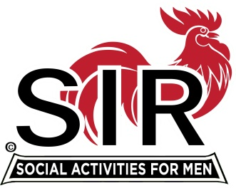
Las Trampas Branch 116
BEC Meeting Agenda
November 18, 2019, 9:30 AM
The Mission of SIR is to enhance the lives of our members through fun activities, events, and luncheons – while making friends for life.
09:15 Coffee Available
09:30 Call to order; Secretary confirm a quorum
09:31 Secretary – Fred Schafer – Approval of October 21 minutes
09:33 Treasurer – Jim Nickels – Report, Budget and Dues for 2020 for approval
09:40 Standing Reports
- Attendance – Jim Flessner – Attendance, Guests- Dr Neil Fruman (Jeff Johnson)
- Membership – Phil Goff – New Members to be inducted- Tim Martin (Darrell Dummett); Al Lundmark (Bob Donohue); Fred McBreen (Don Schroeder); Scott Clark (Tom O’Brien); Returning Chick Walsh (Don Schroeder); Sheldon Lawrence; Form 27 Discussion
- Department Head Reports: Fred Wachowicz – Survey
- Carson City Golf and golf schedule – Bernie Wroblewski
10:00 Big SIR Report – Jerry Hicks
1. Branch Operating Manual - Motion to accept
2. Nominating Committee filled with 5 active members
3. Form 63 (Non Caterer) for 2020 completed
4. Thank you to outgoing Board members
5. Pass down folders
10:10 Little SIR Report – Michael Barrington
1. Speaker: Michael Houston, B-52 pilot in Vietnam era
2. Travel ideas for the Branch; Survey members
10:14 Old Business
- Report on Regional SIR Training Nov. 1; Sam Beret.
- Discuss attendance requirement – 5 of 10 meetings and 3 in a row follow up
10:20 New Business:
- Luncheon Contract with Boundary Oak for approval.
10:25 Closing Remarks, recap of 2019 – Jerry
10:30 Adjourn; Next BEC Meeting, January 20, 2020; Happy Holidays

